Lab 4: Principal Component Analysis — Solutions
  - F71RA Machine Learning for Risk and Insurance 1
Yubo Rasmussen
Table of contents

Before you start
This lab introduces principal component analysis (PCA), our first unsupervised learning method: there is no response variable, and the aim is to describe the structure of a set of correlated variables with fewer, uncorrelated ones. Part 1 runs PCA on the mtcars data and asks what the summary output means. Part 2 interprets the loadings and scores and visualises them in a biplot. Part 3 rebuilds PCA from scratch with matrix algebra from Lab 1, so that nothing princomp() does is a black box. Part 4 applies PCA to a real actuarial question: given a car’s technical specification, is it a sports car?
Learning objectives. By the end of this lab you should be able to
- explain why variables are usually standardised before PCA, and what goes wrong if they are not;
- run princomp() and interpret the standard deviations, proportions of variance, loadings and scores it returns;
- choose a number of components using a scree plot and the eigenvalue-greater-than-one rule;
- draw and interpret a biplot with ggbiplot, including colouring observations by group;
- reproduce princomp() with eigen() and svd(), and explain why signs and scaling can differ between implementations;
- use PCA to build a single data-driven rating variable from several correlated vehicle characteristics.
Packages. Install anything missing with install.packages(). ggbiplot used to be available only on GitHub, so older notes install it with devtools::install_github("vqv/ggbiplot"). It is now on CRAN, so a normal install.packages("ggbiplot") is all you need.
install.packages(c("tidyverse", "ggbiplot"))
library(tidyverse) # loads dplyr, ggplot2, readr and others
library(ggbiplot)

Part 1: PCA on mtcars

The data
We use the built-in mtcars data set, which records 11 characteristics of 32 cars from the 1974 Motor Trend magazine: miles per US gallon (mpg), number of cylinders (cyl), engine displacement in cubic inches (disp), gross horsepower (hp), and so on. Type ?mtcars for the full list.
head(mtcars)
mpg cyl disp hp drat wt qsec vs am gear carb
Mazda RX4 21.0 6 160 110 3.90 2.620 16.46 0 1 4 4
Mazda RX4 Wag 21.0 6 160 110 3.90 2.875 17.02 0 1 4 4
Datsun 710 22.8 4 108 93 3.85 2.320 18.61 1 1 4 1
Hornet 4 Drive 21.4 6 258 110 3.08 3.215 19.44 1 0 3 1
Hornet Sportabout 18.7 8 360 175 3.15 3.440 17.02 0 0 3 2
Valiant 18.1 6 225 105 2.76 3.460 20.22 1 0 3 1
Two columns are categorical even though they look numeric: vs (engine shape: 0 = V-shaped, 1 = straight) and am (transmission: 0 = automatic, 1 = manual). PCA is built on variances and correlations, which only make sense for numeric measurements. A 0/1 code is just a label, so we remove these two columns.
A general warning: many data sets code categorical variables as numbers. Always check what each column means before you feed it to a method.
We store the result under a new name, mtcars_cont, so that the original mtcars is left untouched.
mtcars_cont <- mtcars %>% select(-vs, -am)
names(mtcars_cont)
[1] "mpg" "cyl" "disp" "hp" "drat" "wt" "qsec" "gear" "carb"
Q1. Remove vs and am again using base R only, without dplyr. Hint: see ?which and ?%in%. Then run your code with a column name that does not exist, for example c("vs", "am", "colour"), and also with only names that do not exist, for example c("colour"). What happens in each case? What does this tell you about the -which() idiom?
drop <- c("vs", "am")
# Option 1: negative indexing with which()
mtcars_base1 <- mtcars[, -which(names(mtcars) %in% drop)]
# Option 2: logical indexing
mtcars_base2 <- mtcars[, !names(mtcars) %in% drop]
identical(mtcars_base1, mtcars_cont)
[1] TRUE
identical(mtcars_base2, mtcars_cont)
[1] TRUE
# The trap
ncol(mtcars[, -which(names(mtcars) %in% c("colour"))])
[1] 0
ncol(mtcars[, !names(mtcars) %in% c("colour")])
[1] 11
Answer. Both base R versions give the same data frame as select(-vs, -am). Remember that R indexes from 1, not 0. A name that doesn’t exist is silently ignored as long as at least one other name matches. But if no names match, which() returns integer(0), -integer(0) is still integer(0), and mtcars[, integer(0)] selects zero columns: all the data quietly disappears. The logical version !names(mtcars) %in% drop keeps every column in that case, which is the behaviour we want. dplyr::select() does better still: it stops with an error if you name a column that doesn’t exist. This is one reason dplyr code is safer than hand-written indexing.

Why standardise?
PCA looks for the directions in which the data vary the most. If the variables are measured in different units, “vary the most” depends on those units. princomp() works on the covariance matrix by default. Setting cor = TRUE makes it work on the correlation matrix instead, which is the same as standardising every variable to mean 0 and variance 1 first.
Q2. Run princomp() on mtcars_cont without cor = TRUE, and look at the variances of the original columns. Which variable(s) dominate the first component, and why? Would you trust this analysis?
pca_unscaled <- princomp(mtcars_cont)
summary(pca_unscaled)
Importance of components:
Comp.1 Comp.2 Comp.3 Comp.4
Standard deviation 134.3820274 37.54656204 3.0181295838 1.254845e+00
Proportion of Variance 0.9270116 0.07236743 0.0004676043 8.083193e-05
Cumulative Proportion 0.9270116 0.99937900 0.9998466012 9.999274e-01
Comp.5 Comp.6 Comp.7 Comp.8
Standard deviation 8.904901e-01 6.371404e-01 3.006062e-01 2.814188e-01
Proportion of Variance 4.070624e-05 2.083882e-05 4.638724e-06 4.065453e-06
Cumulative Proportion 9.999681e-01 9.999890e-01 9.999936e-01 9.999977e-01
Comp.9
Standard deviation 2.124807e-01
Proportion of Variance 2.317617e-06
Cumulative Proportion 1.000000e+00
round(unclass(pca_unscaled$loadings)[, 1:2], 3)
Comp.1 Comp.2
mpg 0.038 0.009
cyl -0.012 -0.003
disp -0.900 0.435
hp -0.435 -0.899
drat 0.003 -0.004
wt -0.006 0.005
qsec 0.007 0.025
gear 0.003 -0.011
carb -0.006 -0.028
round(sapply(mtcars_cont, var), 2)
mpg cyl disp hp drat wt qsec gear
36.32 3.19 15360.80 4700.87 0.29 0.96 3.19 0.54
carb
2.61
Answer. Without scaling, the first component explains about 93% of the variance, and its loadings are almost entirely on disp (about 0.90) and hp (about 0.44). The reason is the units, not anything about the cars. disp is measured in cubic inches and has a variance of about 15,000. hp has a variance of about 4,700. Every other variable has a variance below 40. PCA on the covariance matrix just finds “the variable with the biggest numbers”. If displacement were recorded in litres, the result would change completely. We should not trust this analysis. Unless all variables share the same units and scale, use cor = TRUE.

PCA with princomp()
mtcars_pca <- princomp(mtcars_cont, cor = TRUE)
summary(mtcars_pca)
Importance of components:
Comp.1 Comp.2 Comp.3 Comp.4 Comp.5
Standard deviation 2.3782219 1.4429485 0.71008086 0.5148082 0.42797037
Proportion of Variance 0.6284377 0.2313445 0.05602387 0.0294475 0.02035096
Cumulative Proportion 0.6284377 0.8597822 0.91580607 0.9452536 0.96560453
Comp.6 Comp.7 Comp.8 Comp.9
Standard deviation 0.3518426 0.32413257 0.241896155 0.148964367
Proportion of Variance 0.0137548 0.01167355 0.006501528 0.002465598
Cumulative Proportion 0.9793593 0.99103287 0.997534402 1.000000000
Each component Comp.1, …, Comp.9 is a new variable: a weighted sum of the nine standardised original variables. The weights are chosen so that Comp.1 has the largest possible variance, Comp.2 has the largest possible variance while being uncorrelated with Comp.1, and so on. There are as many components as original variables. Together they hold exactly the same information, just rotated.
Q3. Explain to a non-technical colleague, such as an underwriting manager, what the summary table tells us. What are Comp.1 to Comp.9, and what do the rows Standard deviation, Proportion of Variance and Cumulative Proportion mean?
Answer. We started with nine measurements on each car, many of which say similar things: heavy cars tend to have big engines, more cylinders and poor fuel economy. PCA replaces the nine measurements with nine new “summary scores”, ordered from most to least informative.
- Standard deviation: how spread out the cars are on each summary score. Because every original variable was standardised to variance 1, the total variance is 9. A component with standard deviation above 1 (variance above 1) carries more information than a single original variable. Comp.1 has standard deviation 2.38, so variance ${2.38}^{2}≈5.66$, worth more than five original variables.
- Proportion of Variance: each component’s share of the total variance, i.e. its variance divided by 9. Comp.1 captures 62.8% of the differences between the cars and Comp.2 captures 23.1%.
- Cumulative Proportion: the running total. The first two components together capture 86.0%, and the first three capture 91.6%.
In simple terms, almost all of the differences between these 32 cars can be described by two numbers instead of nine. Very little is lost by ignoring the last six or seven components.

How many components?
A scree plot shows the variance of each component in order. A common heuristic, the elbow rule, is to keep the components before the curve flattens out. A second heuristic, Kaiser’s rule, is to keep components whose variance (eigenvalue) is greater than 1, i.e. those that explain more than one original variable’s worth.
scree <- tibble(component = 1:length(mtcars_pca$sdev),
variance = mtcars_pca$sdev^2,
prop = variance / sum(variance))
ggplot(scree, aes(x = component, y = variance)) +
geom_line() +
geom_point() +
geom_hline(yintercept = 1, linetype = "dashed", colour = "red") +
scale_x_continuous(breaks = scree$component) +
labs(x = "Component", y = "Variance (eigenvalue)",
title = "Scree plot, mtcars")
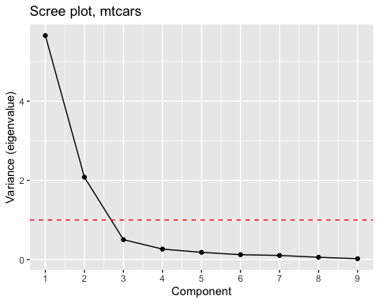
(Base R has a one-line version: screeplot(mtcars_pca, type = "lines").)
Q4. How many components would you keep according to (a) the elbow rule and (b) Kaiser’s rule? Do they agree?
Answer. Only the first two variances, 5.66 and 2.08, are above 1, so Kaiser’s rule keeps two components. The scree plot drops steeply from component 1 to component 3 and is almost flat afterwards. The elbow is at component 3, which suggests keeping two components (the ones before the elbow). Some people would keep three. The two rules broadly agree here, but they are heuristics, not theorems. The right number also depends on what the components will be used for.

Part 2: Loadings, scores and biplots

What does princomp() return?
The output of princomp() is a list. str() shows its elements:
str(mtcars_pca)
List of 7
$ sdev : Named num [1:9] 2.378 1.443 0.71 0.515 0.428 ...
..- attr(*, "names")= chr [1:9] "Comp.1" "Comp.2" "Comp.3" "Comp.4" ...
$ loadings: 'loadings' num [1:9, 1:9] 0.393 -0.403 -0.397 -0.367 0.312 ...
..- attr(*, "dimnames")=List of 2
.. ..$ : chr [1:9] "mpg" "cyl" "disp" "hp" ...
.. ..$ : chr [1:9] "Comp.1" "Comp.2" "Comp.3" "Comp.4" ...
$ center : Named num [1:9] 20.09 6.19 230.72 146.69 3.6 ...
..- attr(*, "names")= chr [1:9] "mpg" "cyl" "disp" "hp" ...
$ scale : Named num [1:9] 5.932 1.758 121.987 67.483 0.526 ...
..- attr(*, "names")= chr [1:9] "mpg" "cyl" "disp" "hp" ...
$ n.obs : int 32
$ scores : num [1:32, 1:9] 0.675 0.647 2.337 0.219 -1.612 ...
..- attr(*, "dimnames")=List of 2
.. ..$ : chr [1:32] "Mazda RX4" "Mazda RX4 Wag" "Datsun 710" "Hornet 4 Drive" ...
.. ..$ : chr [1:9] "Comp.1" "Comp.2" "Comp.3" "Comp.4" ...
$ call : language princomp(x = mtcars_cont, cor = TRUE)
- attr(*, "class")= chr "princomp"
Q5. We asked ChatGPT to “Explain to a lay person what each of the 7 outputs above means.” Here is what it said. Check each description against the documentation (?princomp) and say which are correct, which are misleading, and how you would rewrite the misleading ones.
- sdev: “These are like the speedometers for each trait of the cars, showing how much the models differ for specific characteristics. A higher ‘speed’ means that a characteristic varies significantly among the car models.”
- loadings: “Loadings are like the contribution of each car part to its overall performance. Loadings help us understand the weight of each feature in the components.”
- center: “Think of the center as the ‘average car’ in our dataset. It represents the baseline from which we measure and compare the other cars.”
- scale: “The scale is like the measuring tape we use. It ensures that we fairly compare all cars regardless of their original units.”
- n.obs: “This is the total number of car models we examined in our dataset.”
- scores: “Scores are like individual performance reports for each car, based on the traits we’ve identified. It tells us how each car model performs concerning each trait.”
- call: “This is the specific command we used to generate this analysis. It helps anyone who reads the report understand how the analysis was conducted.”
Answer.
- sdev: misleading. There is one standard deviation per component, not per original “trait” or characteristic. It measures how spread out the cars are along that component. Its square is the component’s variance, i.e. the eigenvalue of the correlation matrix. The “speedometer” analogy adds nothing and suggests a link to car speed that doesn’t exist.
- loadings: half right. Each column holds the weights that define one component as a weighted sum of the standardised original variables. These are the eigenvectors, each with length 1. Read down a column to see which variables a component is made of. “Contribution to overall performance” is wrong: there is no performance variable, and PCA does not predict anything.
- center: correct. These are the means of the original variables, which are subtracted before the analysis. Note that this “average car” is a mix of averages, not a real car in the data.
- scale: mostly correct. These are the standard deviations used to divide each variable, so that all variables are measured on the same scale. One detail: princomp() uses the divisor $n$, not $n−1$, so these values are slightly smaller than sd() gives. With cor = FALSE they would all be 1.
- n.obs: correct. There are 32 cars.
- scores: misleading. The scores are each car’s coordinates on the new components: the value of each weighted sum for that car. They are not a “performance report”. A high score is not better or worse than a low one, and as we will see in Part 3, the sign of a component is arbitrary.
- call: correct. This is the exact function call that produced the object, kept so that the analysis can be reproduced.
The general lesson: AI tools produce fluent analogies that sound right. Always check them against the documentation.

Interpreting the loadings
round(unclass(mtcars_pca$loadings)[, 1:3], 3)
Comp.1 Comp.2 Comp.3
mpg 0.393 0.028 0.221
cyl -0.403 0.016 0.252
disp -0.397 -0.089 0.078
hp -0.367 0.269 0.017
drat 0.312 0.342 -0.150
wt -0.373 -0.172 -0.454
qsec 0.224 -0.484 -0.628
gear 0.209 0.551 -0.207
carb -0.245 0.484 -0.464
Q6. Using the loadings, describe in words what Comp.1 and Comp.2 measure. Which original variables have the largest (absolute) weights on each?
Answer. Comp.1 has weights of roughly equal size (about 0.3 to 0.4) on most variables. mpg and drat have one sign; cyl, disp, hp, wt and carb have the other. It is a size and power axis. It separates big, heavy, powerful, thirsty cars from small, light, economical ones. Comp.2 is dominated by gear, carb and qsec, with gear and carb (and to a lesser extent hp and drat) having the opposite sign to qsec. It is a sportiness axis. It separates cars with many gears and carburettors and quick quarter-mile times (low qsec) from slower-accelerating cars of the same size. The signs themselves don’t matter (see Part 3). What matters is which variables move together and which move in opposite directions.

Biplots
A biplot shows two things at once. The points are the scores of each car on two components (here Comp.1 and Comp.2). The arrows show the loadings of each original variable on those two components. Arrows pointing in a similar direction belong to positively correlated variables. A car lies towards the arrows of the variables on which it scores highly.
ggbiplot(mtcars_pca, labels = rownames(mtcars_cont), labels.size = 3)
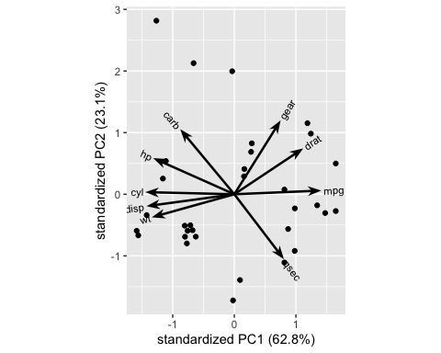
Q7. The default figure is small and the labels overlap. Make it larger in the rendered document, and save a copy to file with specified dimensions.
p_biplot <- ggbiplot(mtcars_pca, labels = rownames(mtcars_cont), labels.size = 3) +
labs(title = "PCA biplot, mtcars") +
theme_minimal()
p_biplot
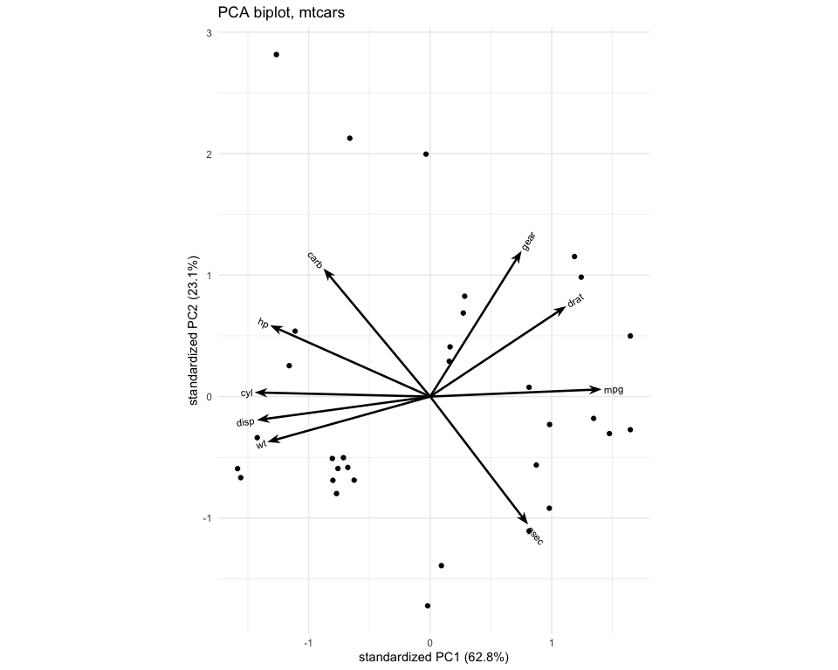
ggsave("mtcars_biplot.png", plot = p_biplot, width = 10, height = 8, dpi = 300)
Answer. In Quarto, the size of a figure in the rendered document is set with the chunk options #| fig-width: and #| fig-height: (in inches). ggsave() writes a ggplot object to file. The file type comes from the extension (.png, .pdf, …), and width, height and dpi control the size and resolution. In RStudio you can also click Zoom in the Plots pane, or Export → Save as Image, which lets you type in the dimensions.

Do cars from the same region look alike?
A reasonable guess is that cars made in the same region share similar properties, because manufacturers design for their home market. We can look for evidence by colouring each car in the biplot by its region of origin. The vector below lists the regions in the same order as the rows of mtcars. Always check a hand-typed vector like this against the row names:
mtcars_country <- c(rep("Japan", 3), rep("US", 4), rep("Europe", 7),
rep("US", 3), "Europe", rep("Japan", 3), rep("US", 4),
rep("Europe", 3), "US", rep("Europe", 3))
tibble(car = rownames(mtcars_cont), country = mtcars_country) %>%
print(n = 32)
# A tibble: 32 × 2
car country
<chr> <chr>
1 Mazda RX4 Japan
2 Mazda RX4 Wag Japan
3 Datsun 710 Japan
4 Hornet 4 Drive US
5 Hornet Sportabout US
6 Valiant US
7 Duster 360 US
8 Merc 240D Europe
9 Merc 230 Europe
10 Merc 280 Europe
11 Merc 280C Europe
12 Merc 450SE Europe
13 Merc 450SL Europe
14 Merc 450SLC Europe
15 Cadillac Fleetwood US
16 Lincoln Continental US
17 Chrysler Imperial US
18 Fiat 128 Europe
19 Honda Civic Japan
20 Toyota Corolla Japan
21 Toyota Corona Japan
22 Dodge Challenger US
23 AMC Javelin US
24 Camaro Z28 US
25 Pontiac Firebird US
26 Fiat X1-9 Europe
27 Porsche 914-2 Europe
28 Lotus Europa Europe
29 Ford Pantera L US
30 Ferrari Dino Europe
31 Maserati Bora Europe
32 Volvo 142E Europe
The groups argument colours each group differently, and ellipse = TRUE draws an ellipse around each group, which makes clusters easier to see.
ggbiplot(mtcars_pca, labels = rownames(mtcars_cont), labels.size = 3,
groups = mtcars_country, ellipse = TRUE) +
labs(colour = "Region") +
theme_minimal()
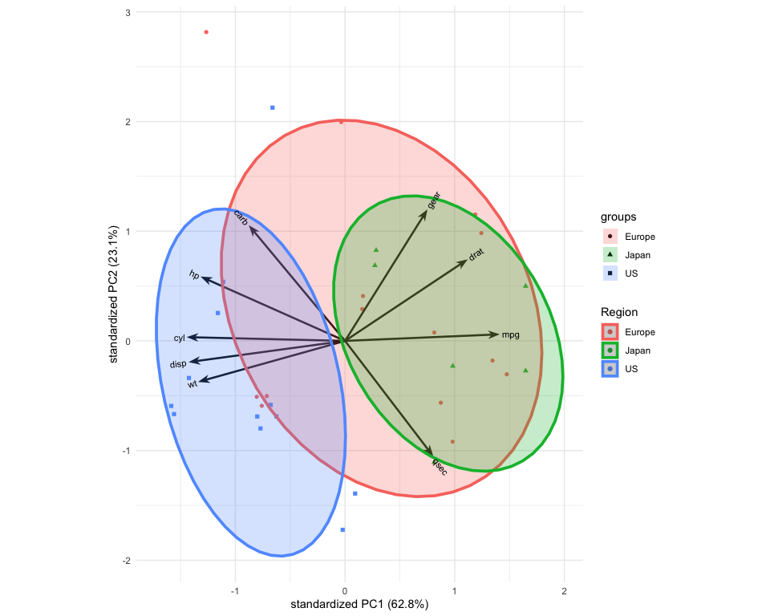
Q8. Does the biplot support the hypothesis? Which region is the most homogeneous, and which the least? Name a car that doesn’t fit its region’s pattern.
Answer. Partly. The US cars sit almost entirely at the heavy, large-engine, low-mpg end of Comp.1 (the Cadillac, Lincoln and Chrysler are the most extreme). The Japanese cars sit at the light, economical end. Both are fairly tight clusters. The European cars are the least homogeneous. Their ellipse stretches along both axes, from economical small cars (Fiat 128, Fiat X1-9) through the mid-sized Mercedes saloons to the Maserati Bora and Ferrari Dino, which stand out on the sportiness axis (Comp.2). The Maserati is closer to the American muscle cars on Comp.1 than to most European cars. So region explains a fair amount of the Comp.1 variation for US and Japanese cars, but “European” is not a single type of car. With only 32 cars, 6 of them Japanese, we should also be careful about generalising.
 Aside: GitHub
Older versions of this lab installed ggbiplot from GitHub. GitHub is a website for storing and sharing code. It keeps a full history of every change to a project, which lets many people work on the same code at once and makes it easy to publish it. Think of it as a shared online folder for software, with “track changes” built in. It has been owned by Microsoft since 2018. Packages on GitHub are often newer or more experimental than those on CRAN, R’s official package repository, which checks packages before accepting them. The course materials for this module are hosted on GitHub too.

Part 3: PCA from scratch
princomp() is not magic. With $Z$ the $n×p$ matrix of standardised data, the correlation matrix is $R=\frac{1}{n−1}Z^{⊤}Z$. PCA is its eigendecomposition,
$$R=VΛV^{⊤},$$
where the columns of $V$ are the loadings (eigenvectors) and the diagonal of $Λ$ holds the component variances (eigenvalues $λ_{1}≥…≥λ_{p}$). The scores are $Y=ZV$. Equivalently, if $Z=UDV^{⊤}$ is the singular value decomposition, then $λ_{j}=d_{j}^{2}/(n−1)$ with the same $V$.
Q9. Compute the eigenvalues and eigenvectors of the correlation matrix of mtcars_cont with eigen(), and compare them with mtcars_pca$sdev^2 and mtcars_pca$loadings. Then check the SVD route. What do you notice about the signs of the eigenvectors? Why can’t PCA pin them down?
Z <- scale(mtcars_cont) # centre, and divide by sd() (divisor n - 1)
eig <- eigen(cor(mtcars_cont))
# eigenvalues vs princomp variances
round(rbind(eigen = eig$values, princomp = mtcars_pca$sdev^2), 4)
Comp.1 Comp.2 Comp.3 Comp.4 Comp.5 Comp.6 Comp.7 Comp.8 Comp.9
eigen 5.6559 2.0821 0.5042 0.265 0.1832 0.1238 0.1051 0.0585 0.0222
princomp 5.6559 2.0821 0.5042 0.265 0.1832 0.1238 0.1051 0.0585 0.0222
# ratio of eigenvectors to princomp loadings: every entry is +1 or -1
round(eig$vectors / unclass(mtcars_pca$loadings), 3)
Comp.1 Comp.2 Comp.3 Comp.4 Comp.5 Comp.6 Comp.7 Comp.8 Comp.9
mpg 1 -1 -1 -1 -1 1 1 -1 -1
cyl 1 -1 -1 -1 -1 1 1 -1 -1
disp 1 -1 -1 -1 -1 1 1 -1 -1
hp 1 -1 -1 -1 -1 1 1 -1 -1
drat 1 -1 -1 -1 -1 1 1 -1 -1
wt 1 -1 -1 -1 -1 1 1 -1 -1
qsec 1 -1 -1 -1 -1 1 1 -1 -1
gear 1 -1 -1 -1 -1 1 1 -1 -1
carb 1 -1 -1 -1 -1 1 1 -1 -1
# SVD route
sv <- svd(Z)
round(sv$d^2 / (nrow(Z) - 1), 4)
[1] 5.6559 2.0821 0.5042 0.2650 0.1832 0.1238 0.1051 0.0585 0.0222
Answer. The eigenvalues agree exactly with the squared standard deviations from princomp(), and so do the SVD values $d_{j}^{2}/(n−1)$. The eigenvectors agree with the loadings up to sign: every entry in a column of the ratio matrix is either $+1$ or $−1$. The reason is that if $v$ is an eigenvector of $R$ then so is $−v$, with the same eigenvalue and the same unit length. Flipping a component’s sign flips the scores of every car on it but changes nothing about the variance explained or the relationships between variables. Different software, or even different versions of the same linear-algebra library, may choose different signs. So never interpret the sign of a component on its own, only the relative signs of the loadings within it.
Q10. Compute the scores by hand as $Y=ZV$, and compare them with mtcars_pca$scores. Then run prcomp(mtcars_cont, scale. = TRUE), R’s other PCA function, and compare its sdev and scores (stored in $x) with princomp(). Explain any differences.
scores_hand <- Z %*% eig$vectors
round(head(mtcars_pca$scores[, 1:3] / scores_hand[, 1:3]), 4)
Comp.1 Comp.2 Comp.3
Mazda RX4 1.016 -1.016 -1.016
Mazda RX4 Wag 1.016 -1.016 -1.016
Datsun 710 1.016 -1.016 -1.016
Hornet 4 Drive 1.016 -1.016 -1.016
Hornet Sportabout 1.016 -1.016 -1.016
Valiant 1.016 -1.016 -1.016
mtcars_prcomp <- prcomp(mtcars_cont, scale. = TRUE)
round(rbind(prcomp = mtcars_prcomp$sdev, princomp = mtcars_pca$sdev), 4)
Comp.1 Comp.2 Comp.3 Comp.4 Comp.5 Comp.6 Comp.7 Comp.8 Comp.9
prcomp 2.3782 1.4429 0.7101 0.5148 0.428 0.3518 0.3241 0.2419 0.149
princomp 2.3782 1.4429 0.7101 0.5148 0.428 0.3518 0.3241 0.2419 0.149
round(head(mtcars_pca$scores[, 1:3] / mtcars_prcomp$x[, 1:3]), 4)
Comp.1 Comp.2 Comp.3
Mazda RX4 -1.016 1.016 -1.016
Mazda RX4 Wag -1.016 1.016 -1.016
Datsun 710 -1.016 1.016 -1.016
Hornet 4 Drive -1.016 1.016 -1.016
Hornet Sportabout -1.016 1.016 -1.016
Valiant -1.016 1.016 -1.016
sqrt(32 / 31)
[1] 1.016001
Answer. The ratio of princomp() scores to hand-computed scores is constant within each column, at $±1.016$. The sign is the arbitrary eigenvector sign from Q9. The factor $1.016=\sqrt{32/31}$ comes from the divisor used to standardise: scale() and prcomp() divide by the sample standard deviation (divisor $n−1$), while princomp() divides by the standard deviation with divisor $n$ (see mtcars_pca$scale). So princomp() scores are slightly larger. The sdev values from prcomp() and princomp() are identical here, because both are square roots of the eigenvalues of the correlation matrix, and a correlation does not depend on the divisor. (With cor = FALSE the sdev values would differ by the same factor $\sqrt{n/(n−1)}$.) The two functions differ only in conventions. Know which one you are using when you compare results with someone else’s.

Part 4: Case study — what is a sports car?
Motor insurers price a vehicle partly on its type, and sports cars are associated with higher claim frequency and severity. But “sports car” has no legal definition. Ingenbleek and Lemaire (1988, ASTIN Bulletin) proposed a statistical classification based on a car’s technical specification. Rentzmann and Wüthrich (2019), Unsupervised learning: What is a sports car?, revisited it with PCA and neural networks, using the data set below. Their tutorial is linked from the Actuarial Data Science page in the course README.
Make sure SportsCars.csv (from the course GitHub page) is in the same folder as this notebook. The file uses semicolons as separators. Each row is a car model, described by:
Variable | Description
brand, type, model | identifiers
cubic_capacity | engine size (cm³)
max_power | maximum power (kW)
max_torque | maximum torque (Nm)
seats | number of seats
weight | weight (kg)
max_engine_speed | maximum engine speed (rpm)
seconds_to_100 | acceleration time, 0–100 km/h (s)
top_speed | top speed (km/h)
sports_car | 1 if classified as a sports car by the Ingenbleek–Lemaire rule
tau | the Ingenbleek–Lemaire index

Task 1: Load and inspect the data
Load the data and inspect it. How many cars and brands are there? Are there missing values? Which columns should not be used as inputs to an unsupervised PCA, and why? Check that sports_car is exactly the rule tau < 17.
cars <- read_delim("SportsCars.csv", delim = ";", show_col_types = FALSE)
glimpse(cars)
Rows: 475
Columns: 13
$ brand <chr> "Austin", "Citroen", "Citroen", "Fiat", "Opel", "Rena…
$ type <chr> "Rovermini", "Visa", "2CV", "Panda", "Ascona2", "R4",…
$ model <chr> "Ehlemayair", "Baseclub", "Specialton", "34", "LS1.6D…
$ cubic_capacity <dbl> 998, 652, 602, 850, 1598, 845, 956, 1588, 1596, 992, …
$ max_power <dbl> 31, 25, 21, 25, 41, 21, 31, 40, 40, 37, 37, 37, 38, 4…
$ max_torque <dbl> 67, 49, 39, 60, 96, 56, 65, 100, 100, 98, 91, 83, 75,…
$ seats <dbl> 4, 5, 4, 5, 5, 4, 5, 5, 5, 5, 5, 5, 5, 5, 5, 5, 4, 5,…
$ weight <dbl> 620, 755, 585, 680, 1015, 695, 695, 900, 1030, 920, 7…
$ max_engine_speed <dbl> 5000, 5500, 5750, 5250, 4600, 4500, 5750, 4500, 4800,…
$ seconds_to_100 <dbl> 19.5, 26.2, NA, 32.3, 21.0, NA, 19.3, 18.7, 20.0, NA,…
$ top_speed <dbl> 129, 125, 115, 125, 143, 115, 137, 148, 140, 130, 150…
$ sports_car <dbl> 0, 0, 0, 0, 0, 0, 0, 0, 0, 0, 0, 0, 0, 0, 0, 0, 0, 0,…
$ tau <dbl> 23.33892, 34.13032, 28.64863, 32.84696, 35.00643, 37.…
n_distinct(cars$brand)
[1] 43
colSums(is.na(cars))
brand type model cubic_capacity
0 0 0 0
max_power max_torque seats weight
0 0 0 0
max_engine_speed seconds_to_100 top_speed sports_car
0 24 0 0
tau
0
table(cars$sports_car)
0 1
403 72
all((cars$tau < 17) == (cars$sports_car == 1))
[1] TRUE
Answer. There are 475 car models from 43 brands, 72 of which (15%) are classified as sports cars. The only missing values are in seconds_to_100 (24 cars), so we either drop that column or lose those rows. princomp() will fail if there are any NAs. The identifiers brand, type and model are labels, not measurements. sports_car and tau are the answers we want to compare against. If we included them as inputs, any agreement we found would be circular. sports_car is exactly tau < 17 for every car.

Task 2: Feature engineering
Following Rentzmann and Wüthrich, we don’t use the raw specifications directly. Instead we use five log-transformed features:
$$x_{1}=log\frac{\text{weight}}{\text{max_power}}, x_{2}=log\frac{\text{max_power}}{\text{cubic_capacity}}, x_{3}=log(\text{max_torque}), x_{4}=log(\text{max_engine_speed}), x_{5}=log(\text{cubic_capacity}).$$
Create these features and compute their correlation matrix. Why might ratios and logs be better inputs than the raw variables?
cars_x <- cars %>%
transmute(x1 = log(weight / max_power),
x2 = log(max_power / cubic_capacity),
x3 = log(max_torque),
x4 = log(max_engine_speed),
x5 = log(cubic_capacity))
round(cor(cars_x), 2)
x1 x2 x3 x4 x5
x1 1.00 -0.75 -0.82 -0.31 -0.67
x2 -0.75 1.00 0.46 0.61 0.15
x3 -0.82 0.46 1.00 -0.11 0.93
x4 -0.31 0.61 -0.11 1.00 -0.25
x5 -0.67 0.15 0.93 -0.25 1.00
Answer. Power, torque, engine size and weight are all positive and right-skewed: a few supercars have enormous values. Taking logs makes the distributions more symmetric and stops a handful of extreme cars from dominating the correlations (recall the claim sizes in Lab 1). Ratios such as weight per kW and kW per litre capture what makes a car “sporty” better than absolute sizes do. A heavy luxury saloon and a light sports car can have the same power. On the log scale a ratio is a difference, so the features combine naturally. The correlation matrix shows strong dependence: torque and engine size are 0.93 correlated, and weight-per-power is strongly negatively correlated with torque (−0.82) and power-per-litre (−0.75). So there is redundancy for PCA to remove.

Task 3: Fit the PCA
Run a standardised PCA on cars_x. How much variance do the first two components explain? How many components would you keep?
cars_pca <- princomp(cars_x, cor = TRUE)
summary(cars_pca)
Importance of components:
Comp.1 Comp.2 Comp.3 Comp.4 Comp.5
Standard deviation 1.7221233 1.2881142 0.52653074 0.2971918 0.097444561
Proportion of Variance 0.5931417 0.3318477 0.05544692 0.0176646 0.001899088
Cumulative Proportion 0.5931417 0.9249894 0.98043632 0.9981009 1.000000000
screeplot(cars_pca, type = "lines", main = "Scree plot, sports cars")
abline(h = 1, lty = 2, col = "red")
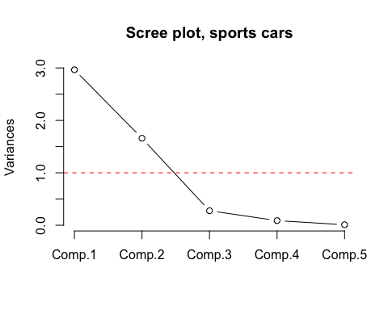
Answer. The first component explains 59.3% of the variance and the second 33.2%, so two components capture 92.5% of the information in five features. The variances are 2.97, 1.66, 0.28, 0.09 and 0.01. Only the first two are above 1, and the scree plot has a clear elbow at component 3. Both rules say to keep two components.

Task 4: Interpret the components
Print the loadings of the first two components and describe each in words.
round(unclass(cars_pca$loadings)[, 1:2], 3)
Comp.1 Comp.2
x1 0.558 0.103
x2 -0.412 -0.482
x3 -0.539 0.268
x4 -0.126 -0.705
x5 -0.461 0.434
Answer. On Comp.1, weight-per-power ($x_{1}$, loading about 0.56 in absolute value) has the opposite sign to torque ($x_{3}$, 0.54), engine size ($x_{5}$, 0.46) and power-per-litre ($x_{2}$, 0.41). It is a performance axis: cars at one end are heavy for their power, cars at the other have big, strong engines relative to their weight. Comp.2 is dominated by maximum engine speed ($x_{4}$, about 0.71) and power-per-litre ($x_{2}$, 0.48), which have the opposite sign to engine size ($x_{5}$, 0.43) and torque ($x_{3}$, 0.27). It describes how an engine produces its power: small, high-revving, highly tuned engines at one end, and large, low-revving, high-torque engines at the other.

Task 5: Biplot
Draw a biplot of the first two components, coloured by sports_car. With 475 cars, labels would be unreadable, so leave them out and use alpha to make the points semi-transparent. Do the sports cars form a distinct group?
ggbiplot(cars_pca, groups = factor(cars$sports_car, labels = c("No", "Yes")),
ellipse = TRUE, alpha = 0.5) +
labs(colour = "Sports car") +
theme_minimal()
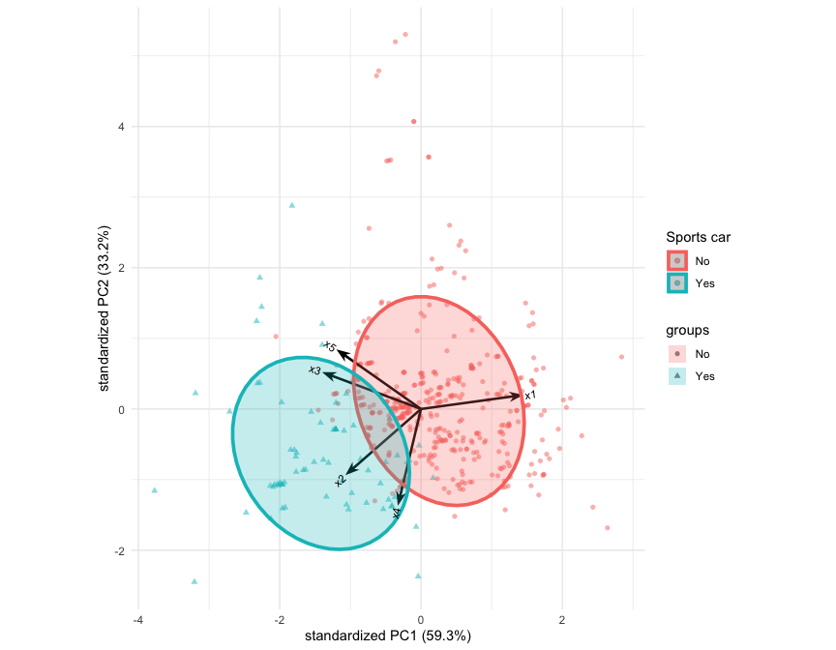
Answer. Yes, mostly. The sports cars sit at one end of Comp.1: the end where the torque, engine size and power-per-litre arrows point, and opposite the weight-per-power arrow. They are spread out along Comp.2, which contains both high-revving small-engined sports cars and large-engined ones. The two ellipses overlap, so Comp.1 separates the groups well but not perfectly. It is striking that PCA never saw the sports_car label, yet the direction of greatest variation in the data lines up closely with it.

Task 6: A PCA-based sports car rule
We now use Comp.1 as a one-number “sportiness” score. Because the sign of a component is arbitrary (Part 3), we first orient it so that higher values mean more weight per kW, i.e. less sporty. Then:
- compute the correlation between this score and tau;
- flag as “sporty” the 72 cars with the lowest score, the same number the Ingenbleek–Lemaire rule flags;
- cross-tabulate the PCA classification against sports_car.
pc1 <- cars_pca$scores[, 1] * sign(cars_pca$loadings["x1", 1])
cars <- cars %>%
mutate(pc1 = pc1,
pc_sporty = rank(pc1) <= sum(sports_car))
cor(cars$pc1, cars$tau)
[1] 0.8333832
table(PCA = cars$pc_sporty, Expert = cars$sports_car)
Expert
PCA 0 1
FALSE 384 19
TRUE 19 53
mean(cars$pc_sporty == (cars$sports_car == 1))
[1] 0.92
Answer. The oriented Comp.1 score has a correlation of about 0.83 with tau. Of the 72 cars with the lowest scores, 53 are sports cars under the Ingenbleek–Lemaire rule, so 19 sports cars are missed and 19 others are flagged instead. Overall the two rules agree on 92% of cars. That is good agreement for a score built without ever seeing the label. The disagreements are informative too: tau is (almost) a function of the same five features, but not a linear combination of them, and Comp.1 holds only 59% of their variance. Some of the information that matters for tau is in Comp.2. Rentzmann and Wüthrich show that a nonlinear generalisation of PCA, the autoencoder, which we meet later in the course, does better.
Q11. Why might an insurer prefer a continuous score like pc1 to a 0/1 “sports car” flag as a rating factor in a GLM like the ones in Lab 3? Can you think of a disadvantage?
Answer. A 0/1 flag throws information away: a car just above the threshold is treated the same as a family estate, and one just below it the same as a supercar. A continuous score allows the premium to rise smoothly with sportiness. It also replaces five strongly correlated features with one (or two) uncorrelated variables, which avoids the multicollinearity problems we saw with cyl, hp and wt in Lab 3. And new car models can be scored as soon as their specification is known, before any claims data exist. Disadvantages: the score is harder to explain to customers and regulators than “this is a sports car”. PCA chooses the direction of greatest variance, which need not be the direction most related to claims, because PCA never looks at the response. And the score’s meaning (and sign) changes if the PCA is refitted on new data, so the loadings must be fixed and documented.

Stretch: principal component regression
In Lab 3 we saw that correlated predictors make individual regression coefficients unstable. Principal component regression (PCR) replaces the predictors with their first few principal components. These are uncorrelated by construction.
Run a PCA on the eight predictors of mpg in mtcars_cont, leaving out mpg itself. Fit (i) lm(mpg ~ .) on all eight original predictors and (ii) regressions of mpg on the first one, two and three component scores. Compare the coefficient tables and the adjusted $R^{2}$.
X_pca <- princomp(mtcars_cont %>% select(-mpg), cor = TRUE)
summary(X_pca)
Importance of components:
Comp.1 Comp.2 Comp.3 Comp.4 Comp.5
Standard deviation 2.1920812 1.4422829 0.69433578 0.51480189 0.41808167
Proportion of Variance 0.6006525 0.2600225 0.06026277 0.03312762 0.02184904
Cumulative Proportion 0.6006525 0.8606750 0.92093775 0.95406537 0.97591440
Comp.6 Comp.7 Comp.8
Standard deviation 0.33025522 0.244571091 0.154276502
Proportion of Variance 0.01363356 0.007476877 0.002975155
Cumulative Proportion 0.98954797 0.997024845 1.000000000
pcr_dat <- data.frame(mpg = mtcars_cont$mpg, X_pca$scores)
full <- lm(mpg ~ ., data = mtcars_cont)
pcr1 <- lm(mpg ~ Comp.1, data = pcr_dat)
pcr2 <- lm(mpg ~ Comp.1 + Comp.2, data = pcr_dat)
pcr3 <- lm(mpg ~ Comp.1 + Comp.2 + Comp.3, data = pcr_dat)
summary(full)$coefficients
Estimate Std. Error t value Pr(>|t|)
(Intercept) 17.88963741 17.81995814 1.0039102 0.32586753
cyl -0.41459575 0.95765329 -0.4329289 0.66909919
disp 0.01293240 0.01757840 0.7356985 0.46935104
hp -0.02084886 0.02072221 -1.0061121 0.32482989
drat 1.10109551 1.59806015 0.6890201 0.49770317
wt -3.92064847 1.86174262 -2.1059025 0.04633293
qsec 0.54145693 0.62121600 0.8716081 0.39242987
gear 1.23321026 1.40237652 0.8793717 0.38829523
carb -0.25509911 0.81562616 -0.3127648 0.75727771
summary(pcr2)$coefficients
Estimate Std. Error t value Pr(>|t|)
(Intercept) 20.0906250 0.4594500 43.7275551 4.990380e-28
Comp.1 -2.4560127 0.2095953 -11.7178783 1.611380e-12
Comp.2 0.1987401 0.3185575 0.6238751 5.375866e-01
sapply(list(full = full, pcr1 = pcr1, pcr2 = pcr2, pcr3 = pcr3),
function(m) round(summary(m)$adj.r.squared, 3))
full pcr1 pcr2 pcr3
0.811 0.818 0.814 0.829
Answer. In the full model only wt is significant at the 5% level ($|t|≈2.1$), even though the model explains 86% of the variance. This is the multicollinearity pattern from Lab 3 Q7. The PCR with a single component has a slightly higher adjusted $R^{2}$ (about 0.818 vs 0.811) using one coefficient instead of eight, and that coefficient is extremely significant ($|t|≈11.8$). Adding Comp.2 doesn’t help ($|t|≈0.6$), even though Comp.2 explains 26% of the predictors’ variance. This shows PCR’s main weakness: components are chosen for how much of the predictors’ variance they explain, not for how well they predict the response. Comp.3 is close to significance and raises the adjusted $R^{2}$ to about 0.829. Methods that choose the components with the response in mind, such as partial least squares, address this weakness.

